Install Power BI Desktop

If Microsoft Power BI Desktop is not already installed on your Windows computer, you can download and install it for free.

1. Download the Power BI Desktop installer from [https://aka.ms/power-bi-desktop](https://aka.ms/power-bi-desktop?azure-portal=true).
2. When the file has downloaded, open it, and use the setup wizard to install Power BI Desktop on your computer. This insatllation may take a few minutes.

Import data

1. Open Power BI Desktop. The application interface should look similar to this:

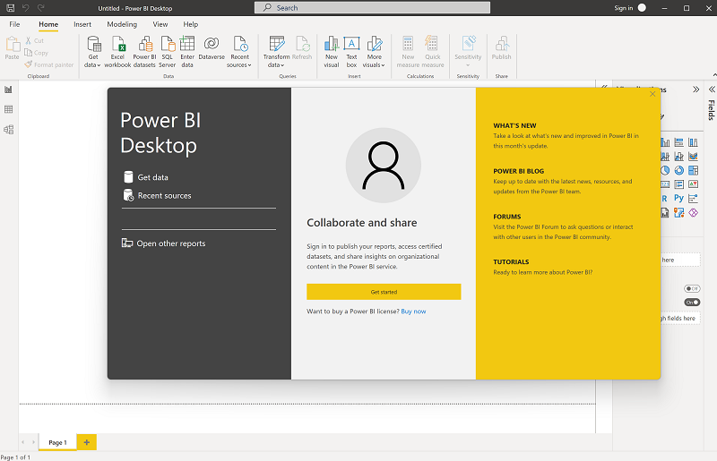

Now you're ready to import the data for your report.

1. On the Power BI Desktop welcome screen, select **Get data**, and then in the list of data sources, select **Web** and then select **Connect**.

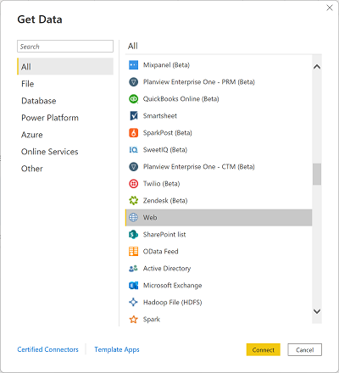

1. In the **From web** dialog box, enter the following URL and then select **OK**:

https://github.com/MicrosoftLearning/DP-900T00A-Azure-Data-Fundamentals/raw/master/power-bi/customers.csv

1. In the Access Web content dialog, select **Connect**.
2. Verify that the URL opens a dataset containing customer data, as shown below. Then select **Load** to load the data into the data model for your report.

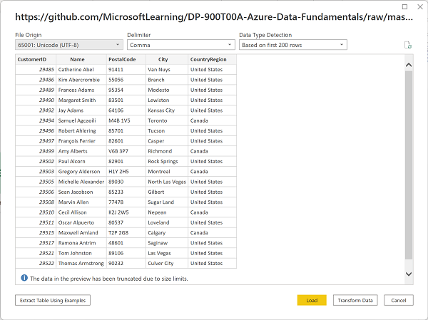

1. In the main Power BI Desktop window, in the Data menu, select **Get data**, then select **Web**:

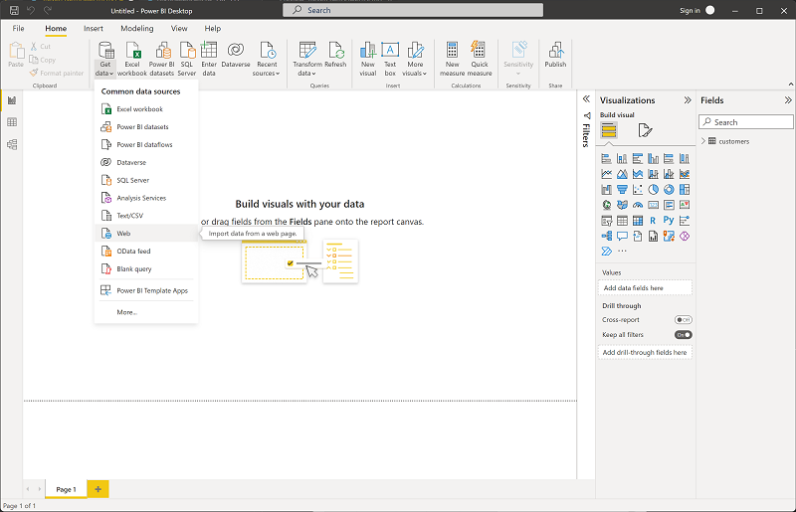

1. In the **From web** dialog box, enter the following URL and then select **OK**:

https://github.com/MicrosoftLearning/DP-900T00A-Azure-Data-Fundamentals/raw/master/power-bi/products.csv

1. In the dialog, select **Load** to load the product data in this file into the data model.
2. Repeat the previous three steps to import a third dataset containing order data from the following URL:

https://github.com/MicrosoftLearning/DP-900T00A-Azure-Data-Fundamentals/raw/master/power-bi/orders.csv

Explore a data model

The three tables of data you've imported have been loaded into a data model, which you'll now explore and refine.

1. In Power BI Desktop, on the left-side edge, select the **Model** tab, and then arrange the tables in the model so you can see them. You can hide the panes on the right side by using the **>>** icons:

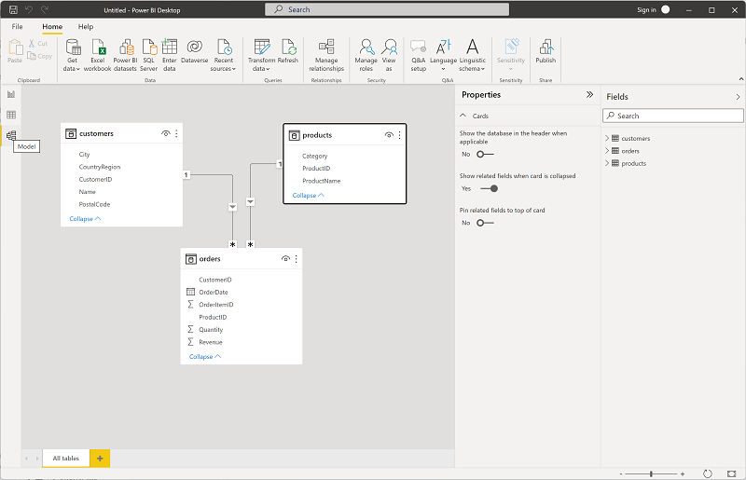

1. In the **orders** table, select the **Revenue** field and then in the **Properties** pane, set its **Format** property to **Currency**:

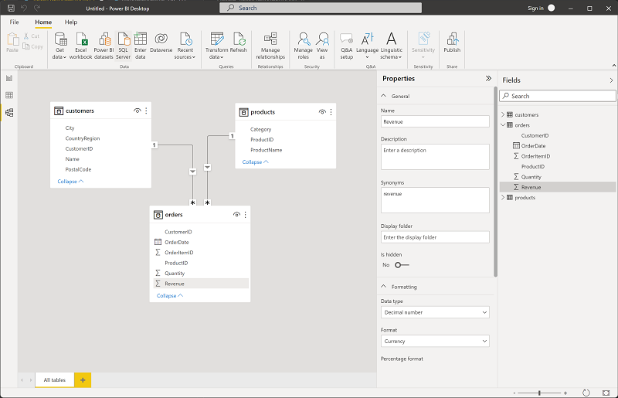

This step will ensure that revenue values are displayed as currency in report visualizations.

1. In the products table, right-click the **Category** field (or open its **⋮** menu) and select **Create hierarchy**. This step creates a hierarchy named **Category Hierarchy**. You may need to expand or scroll in the **products** table to see this - you can also see it in the **Fields** pane:

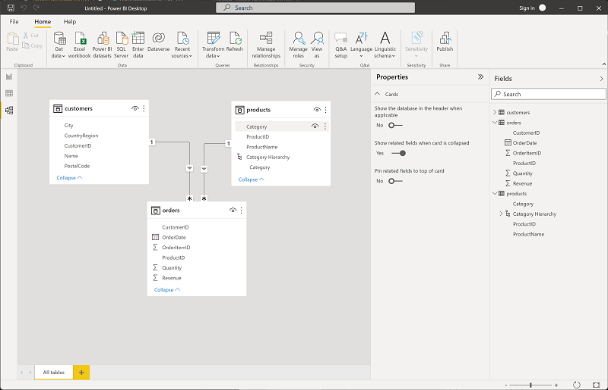

1. In the products table, right-click the **ProductName** field (or open its **⋮** menu) and select **Add to hierarchy** > **Category Hierarchy**. This adds the **ProductName** field to the hierarchy you created previously.
2. In the **Fields** pane, right-click **Category Hierarchy** (or open its **…** menu) and select **Rename**. Then rename the hierarchy to **Categorized Product**.

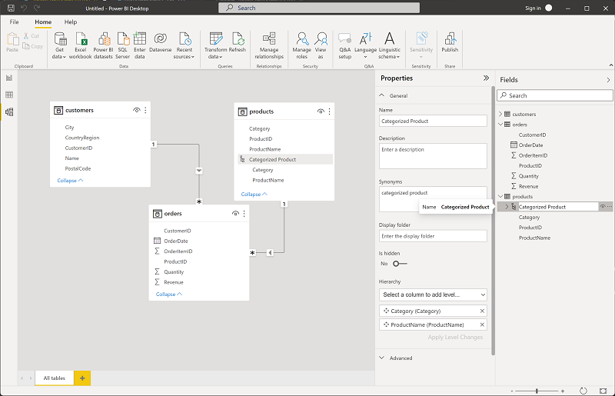

1. On the left-side edge, select the **Data view** tab, and then in the **Data** pane, select the **customers** table.
2. Select the **City** column header, and then set its **Data Category** property to **City**:

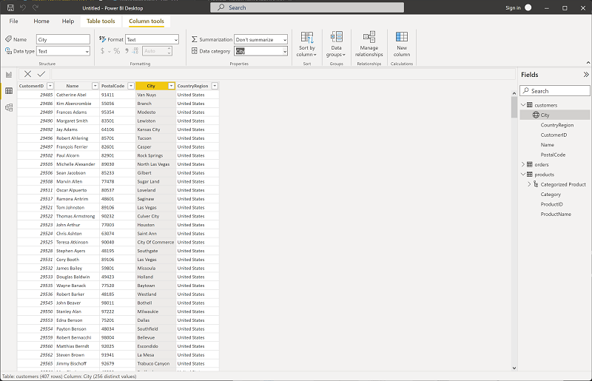

This step will ensure that the values in this column are interpreted as city names, which can be useful if you intend to include map visualizations.

Create a report

Now you're almost ready to create a report. First you need to check some settings to ensure all visualizations are enabled.

1. On the **File** menu, select **Options and Settings**. Then select **Options**, and in the **Security** section, ensure that **Use Map and Filled Map visuals** is enabled and select **OK**.

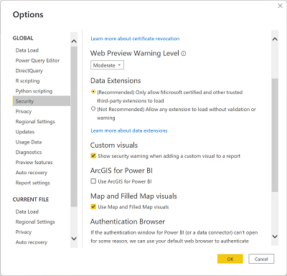

This setting ensures that you can include map visualizations in reports.

1. On the left-side edge, select the **Report view** tab and view the report design interface.

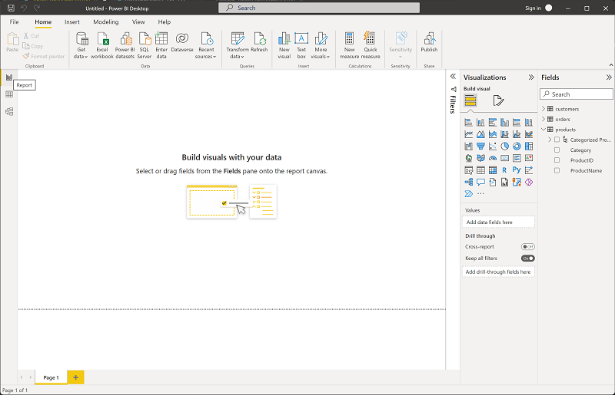

1. In the ribbon, above the report design surface, select **Text Box** and add a text box containing the text **Sales Report** to the report. Format the text to make it bold with a font size of 32.

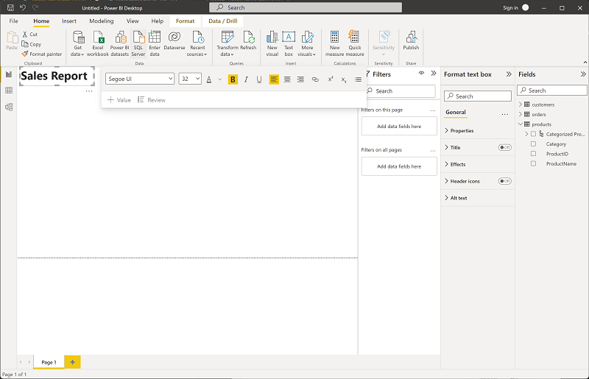

1. Select any empty area on the report to de-select the text box. Then in the **Data** pane, expand **Products** and select the **Categorized Products** field. This step adds a table to the report.

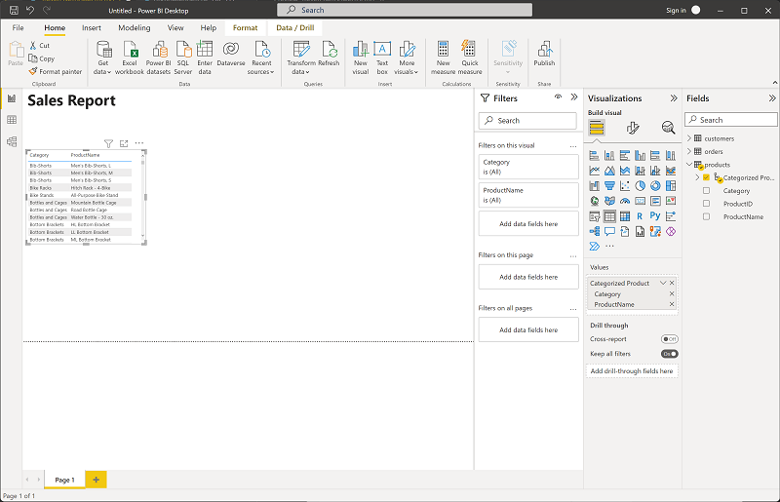

1. With the table still selected, in the **Data** pane, expand **Orders** and select **Revenue**. A Revenue column is added to the table. You may need to expand the size of the table to see it.

The revenue is formatted as currency, as you specified in the model. However, you didn't specify the number of decimal places, so the values include fractional amounts. It won't matter for the visualizations you're going to create, but you could go back to the **Model** or **Data** tab and change the decimal places if you wish.

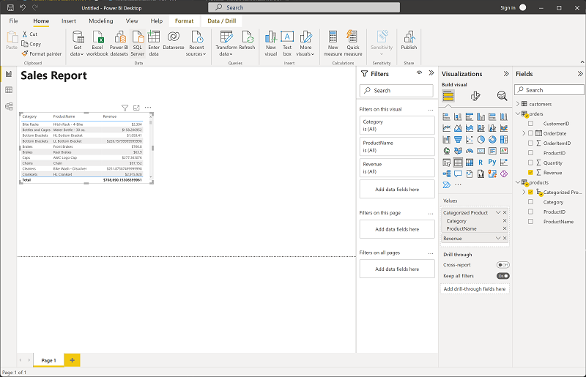

1. With the table still selected, in the **Visualizations** pane, select the **Stacked column chart** visualization. The table is changed to a column chart showing revenue by category.

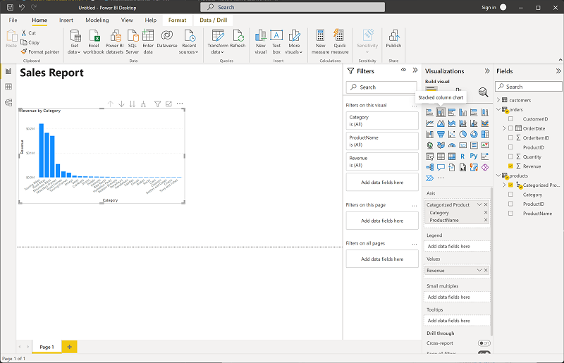

1. Above the selected column chart, select the **↓** icon to turn on drill-down. Then in the chart, select the second column to drill down and see the revenue for the individual products in this category. This capability is possible because you defined a hierarchy of categories and products.

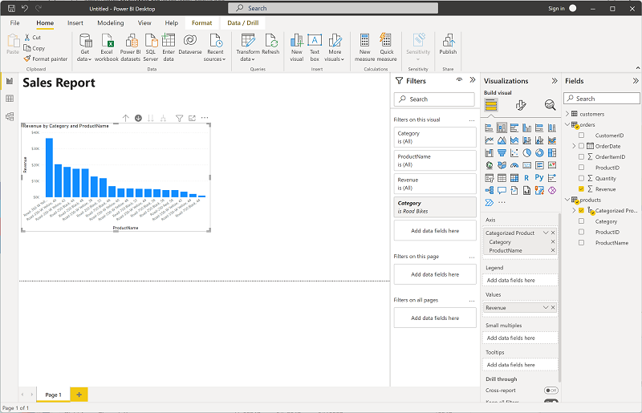

1. Use the **↑** icon to drill back up to the category level. Then select the **(**↓**)** icon to turn off the drill-down feature.
2. Select a blank area of the report, and then in the **Data** pane, select the **Quantity** field in the **orders** table and the **Category** field in the **products** table. This step results in another column chart showing sales quantity by product category.
3. With the new column chart selected, in the **Visualizations** pane, select **Pie chart** and then resize the chart and position it next to the revenue by category column chart.

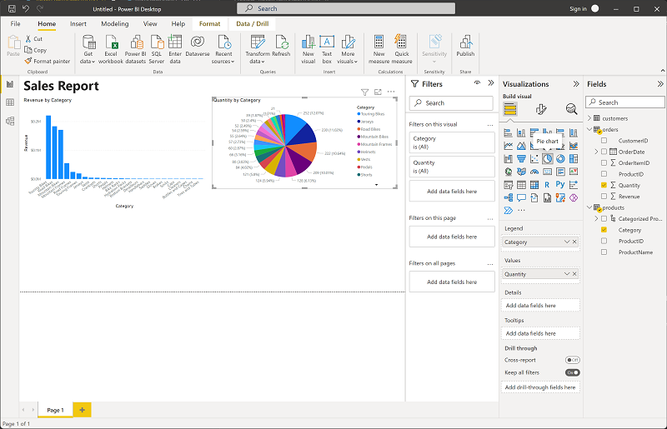

1. Select a blank area of the report, and then in the **Data** pane, select the **City** field in the **customers** table and then select the **Revenue** field in the **orders** table. This results in a map showing sales revenue by city. Rearrange and resize the visualizations as needed:

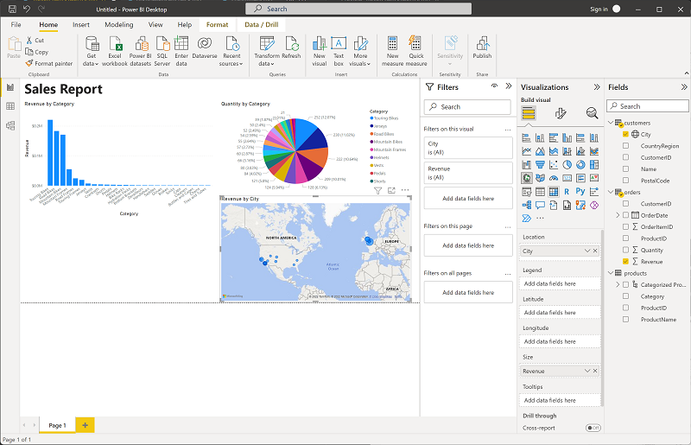

1. In the map, note that you can drag, double-click, use a mouse-wheel, or pinch and drag on a touch screen to interact. Then select a specific city, and note that the other visualizations in the report are modified to highlight the data for the selected city.

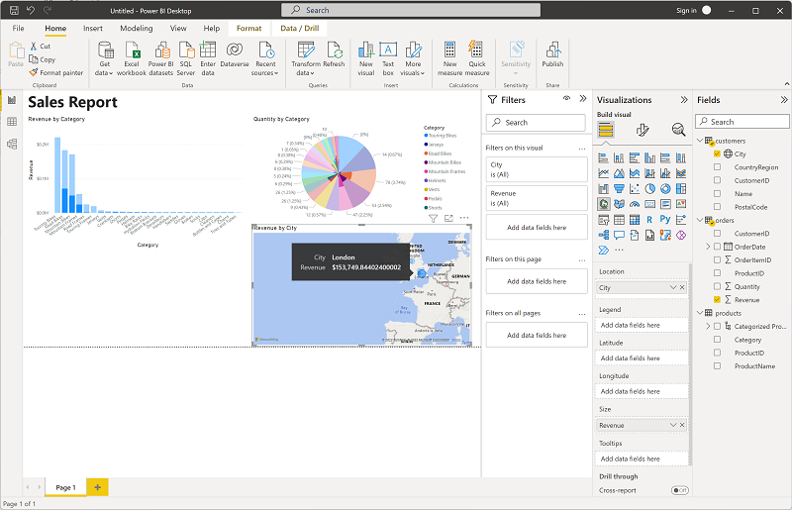

1. On the **File** menu, select **Save**. Then save the file with an appropriate .pbix file name. You can open the file and explore data modeling and visualization further at your leisure.